IO
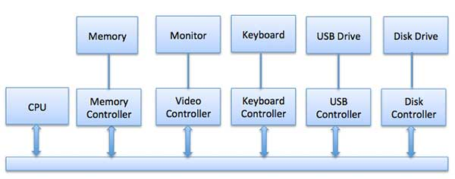
Hardware:

Device controllers/IO Types/DMA
- block = access is independant e.g (disk)
- character = access is serial e.g (external device)
DMA = Direct Memory Access (DMA):

Data transfer between I/O and memory
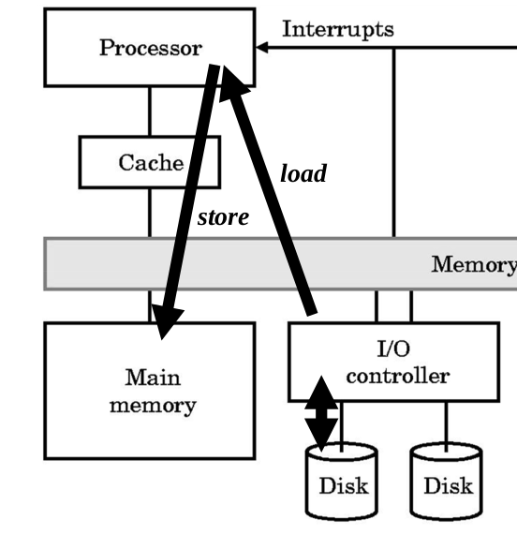(a)
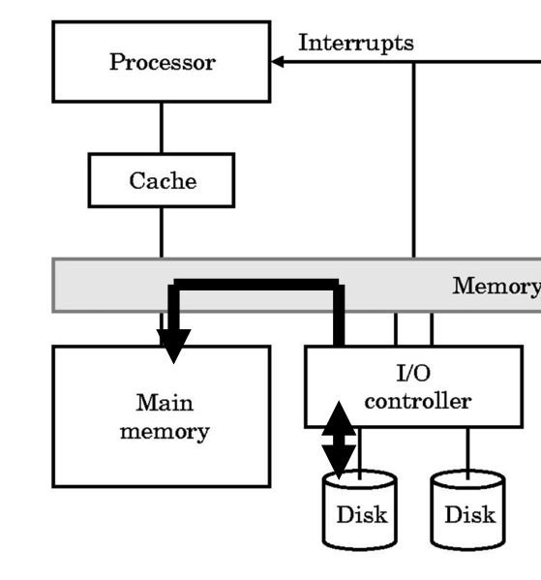(b)
- (a) load and store operations
- (b) DMA (without using the CPU)

Software:
Interrupt Handler = code handler (wait/timing)
